Agenda- To send emails for a customer depending on his relationship days(Here Relationship Days means when the customer has seen the offer from the start.

For this we need to create a data type that is the Data Model and then we need to save the context dictionary. And then we need to build our NBA Designer Template on the class.  
By default it will be on the class PegaMKT-Data-Customer. And whatever the class that you create data class(Data type) should be referencing this.   
**MOST IMPORTANTLY WE NEED TO ADD 3 PROPERTIES WHENEVER WE CREATE OUR DATA MODEL THOSE PROPERTIES ARE**

pyemail1- (Participant Email

pyMobilephone- mobile phone

pyFullName- Full Name

**AND MAKE SURE THAT YOU ARE GIVING THE DATABASE AS EXTERNALMKTDATA**

all these should be added and the key must be Customer ID and the property should be added from the class PegaMKT-Data-Customer.

After that we need to add the records which we need and other properties which we think might be needed and then we must give external mapping In order to see the data in the profile designer of the portal.

And also the main important thing is targetted set of audience which is defined under Segments.

Segment means target set of customers and that we need to send the offers.

By default prospect and customer are the data types provided by CDH to us

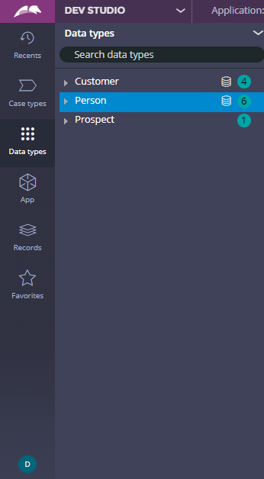

I created my own Data Type and this is the one

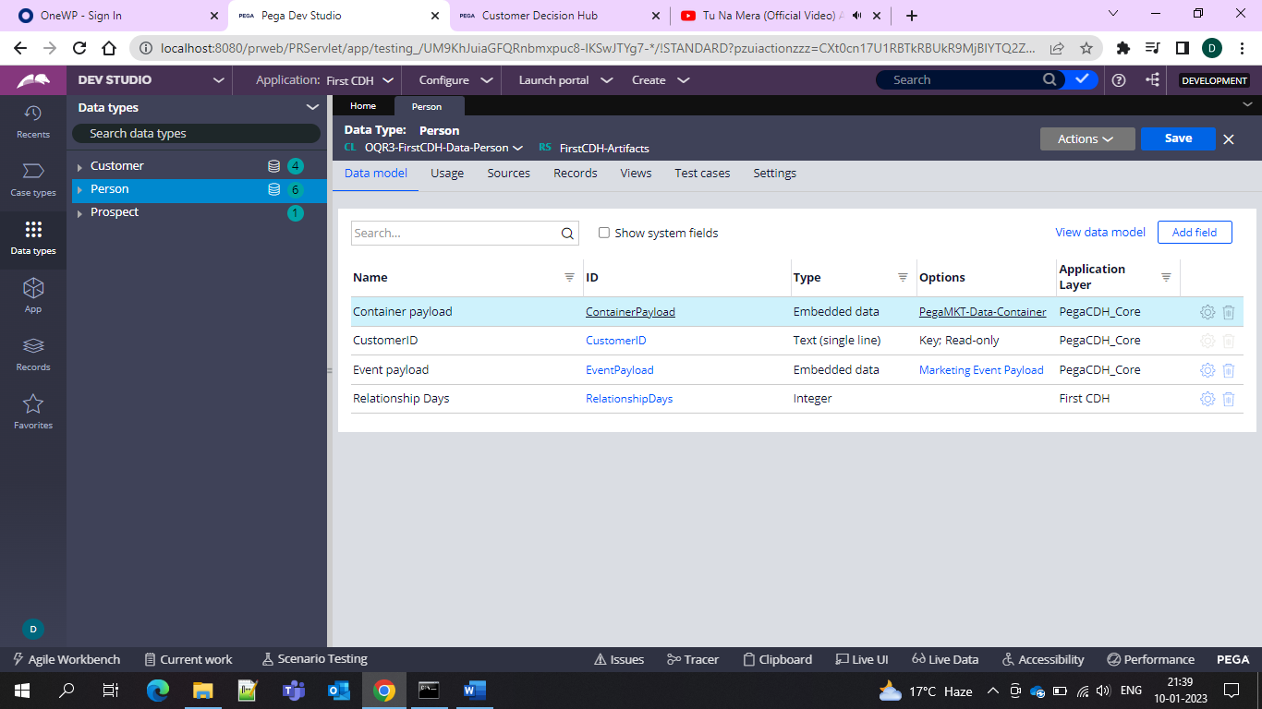

After this go to app studio and then do a context save

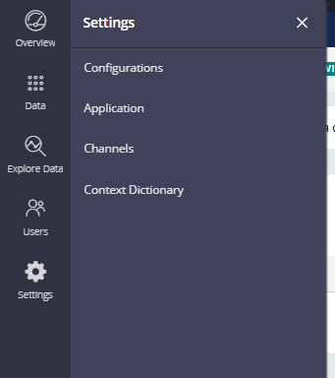

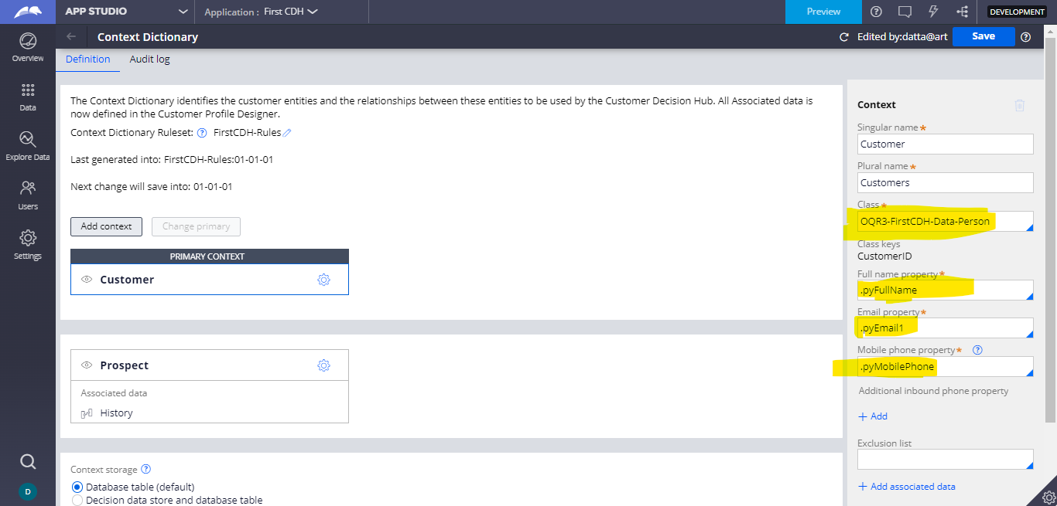

and then we need to save then an dialog box is displayed and then we need to select the Option as Overwrite all rules

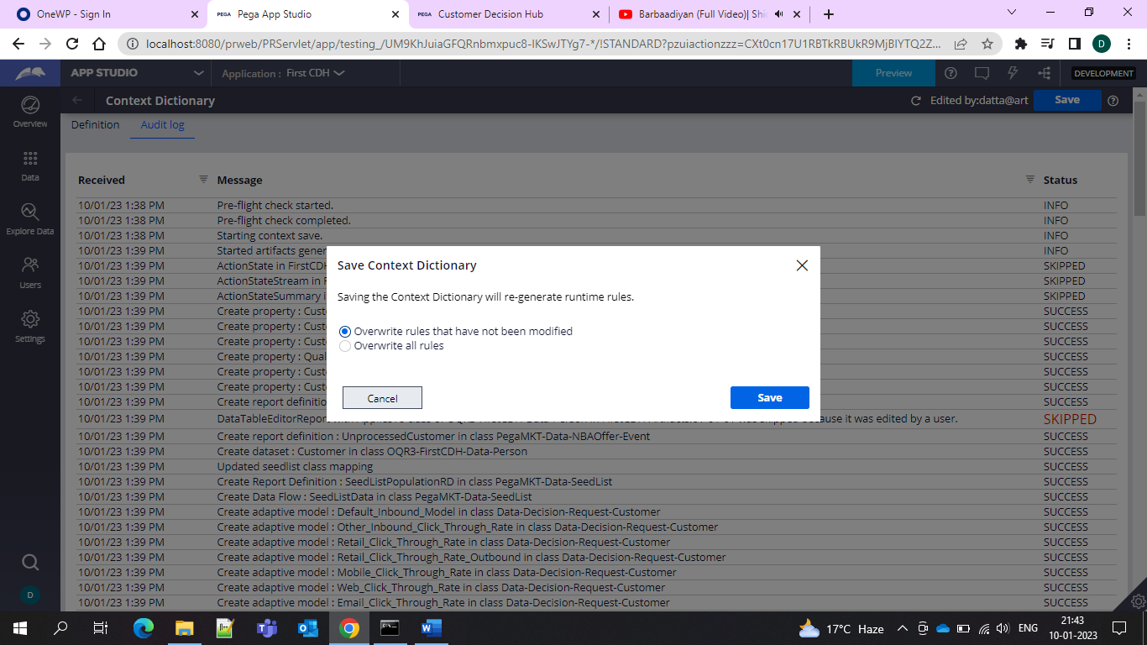

And after that context is saved.

And after that you need to create a blank template and enable the NBA Designer.

And now we need to create offers and for this first we need to create issue/Groups from the CDH portal.

My issue is Onboard and under that we have groups as Loans/Credit Cards and we can create under the Taxonomy.

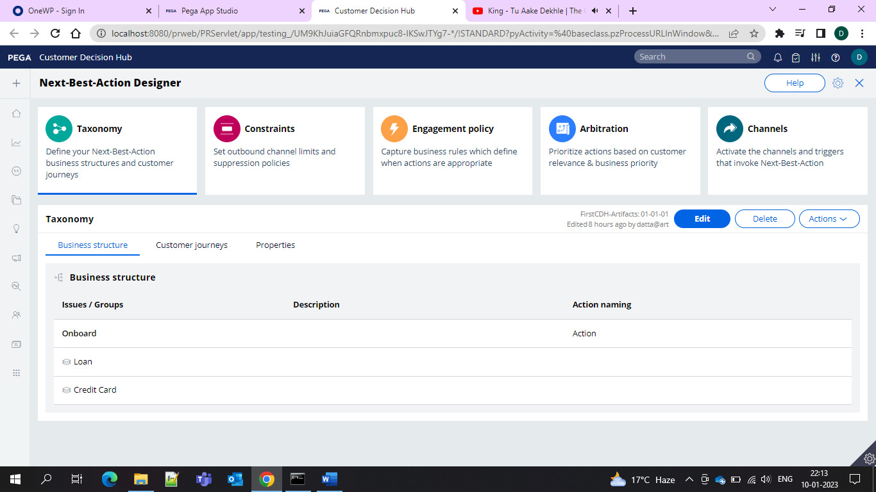

And after that we need to save the engagement policy once and make sure under arbitration all are enabled and under channels all are enabled.

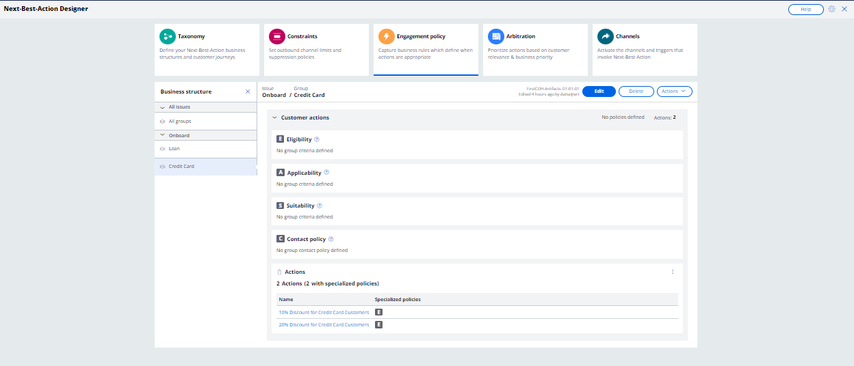

And now after the save only the engagement would work under the Actions. Now let’s create an Action for new customer as 10% Discount for the 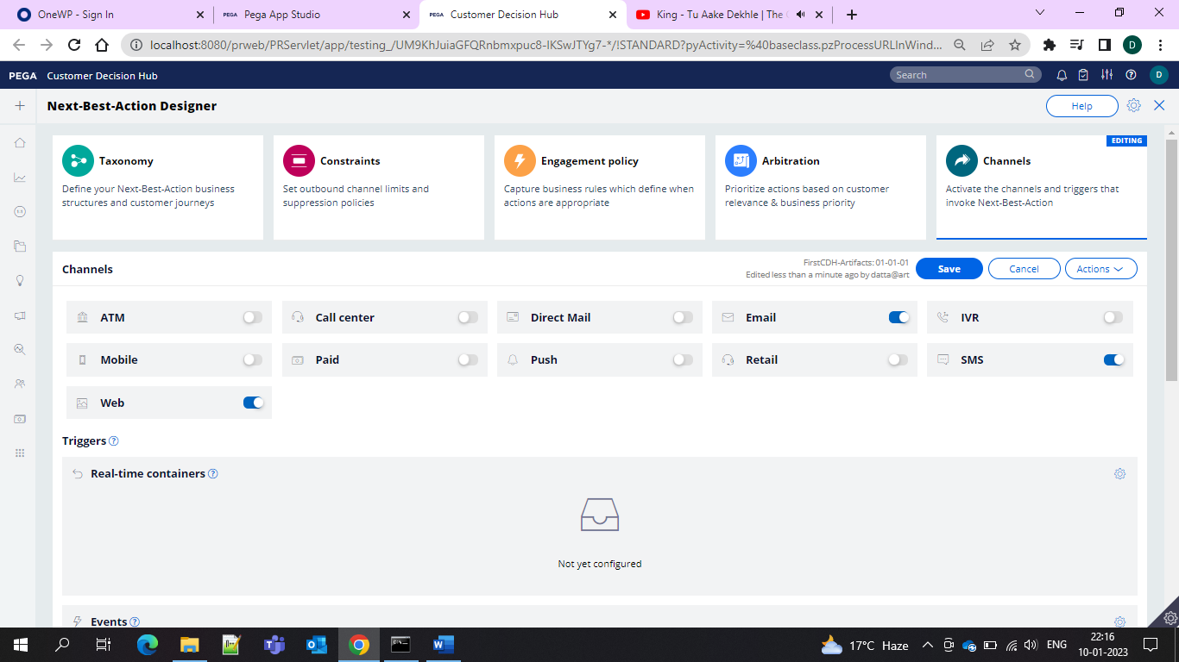

And also enable the channels presently I am enabling the channels In this I want to work on the Email.

And then we need to make sure that the Email treatment is running as success.

By Default Default email is picked up for the Email processing otherwise we can specify the email under the Action.

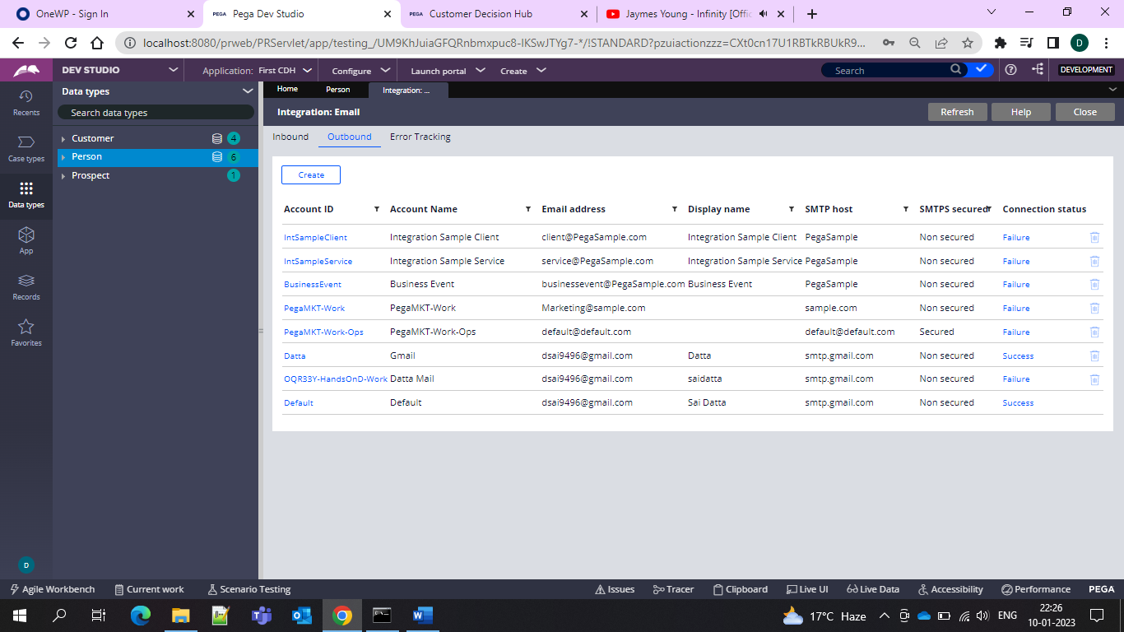

For me both are success

And then we need to create action for the new customer if relationship day is 1 and if the relationship day extends then we have to send different email is relationship day is more than 3

So the action can be created from the **content>Actions**

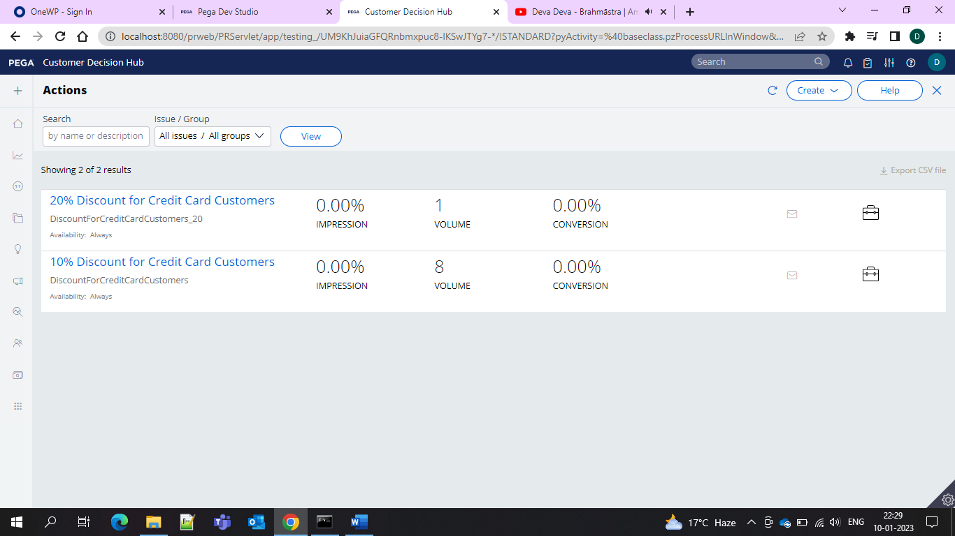

So 2 different actions based on the relationship days and this we need to give under the engagement policy of the action.

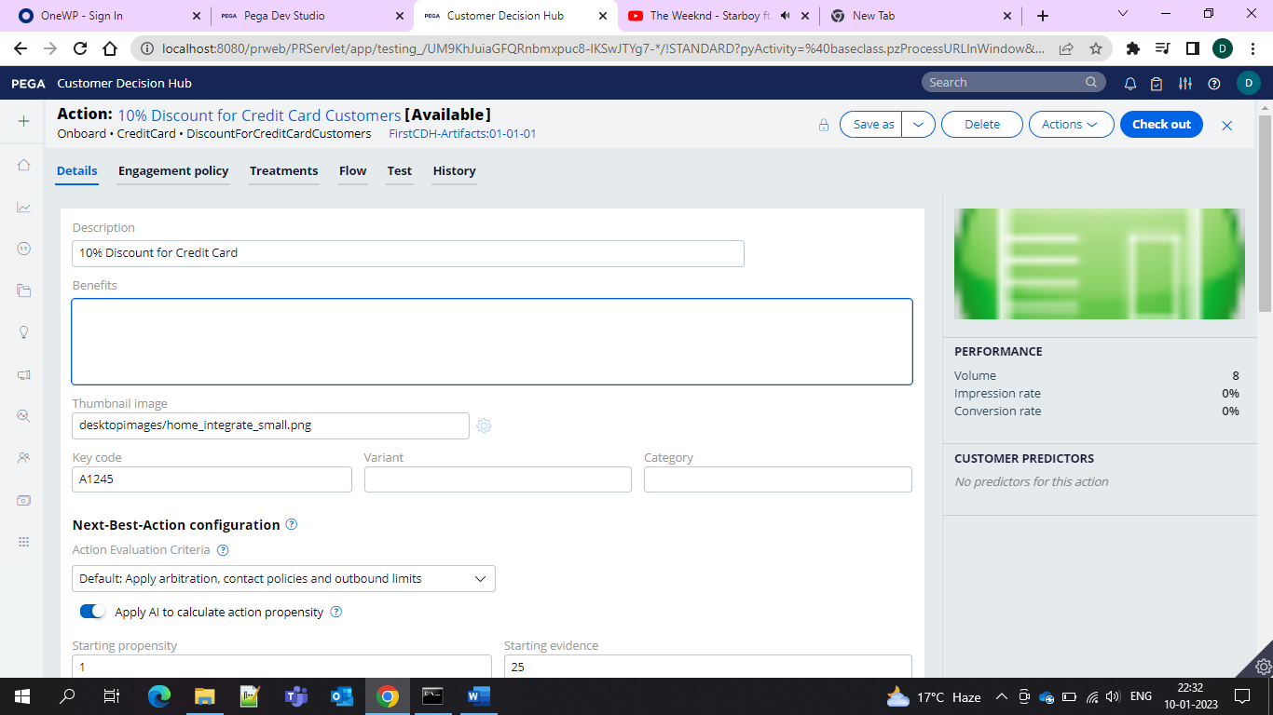

Give the description and the code and then go to the treatment tab and create email treatment

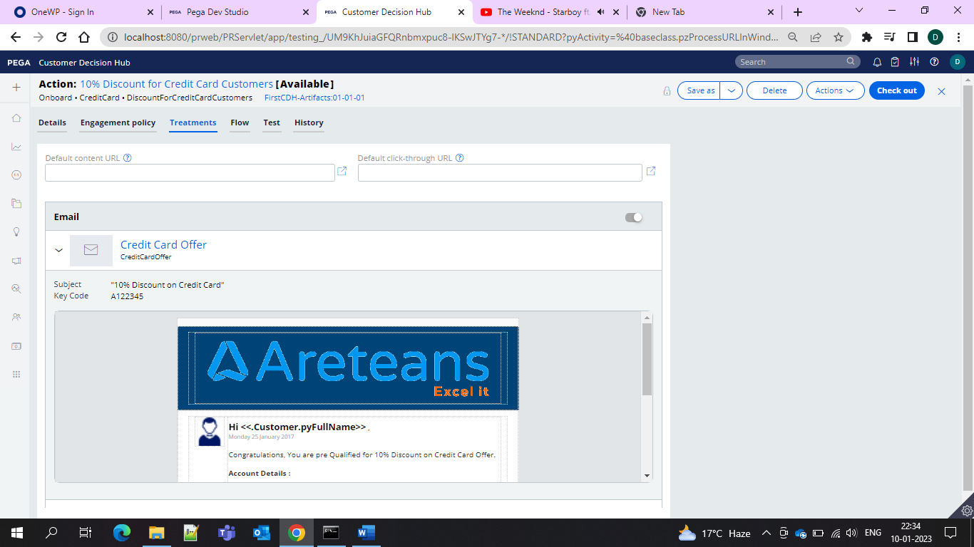

And when we open the email treatment and then under the flow which is called as the offer flow and we need to give a shape as Send email in order to trigger the flow

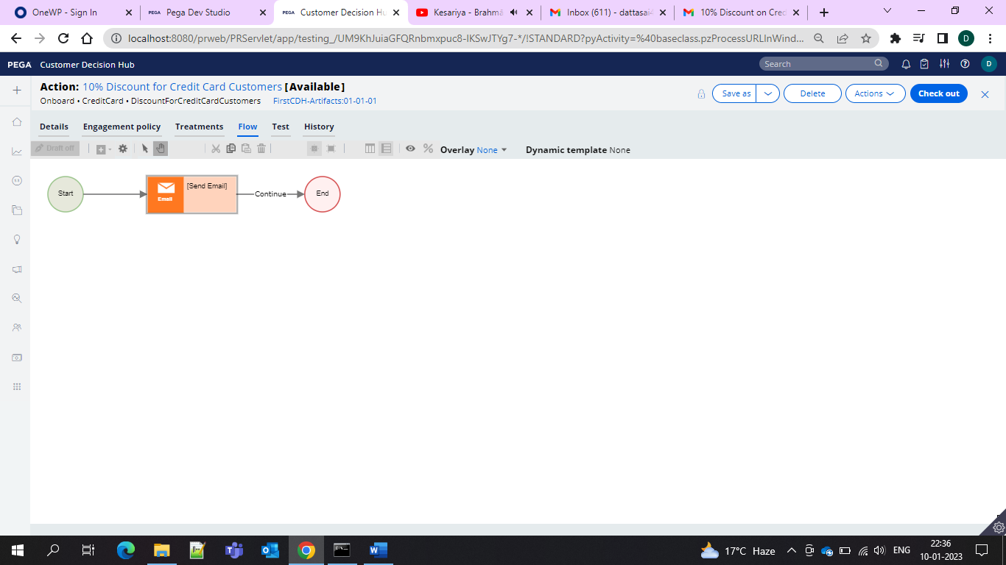

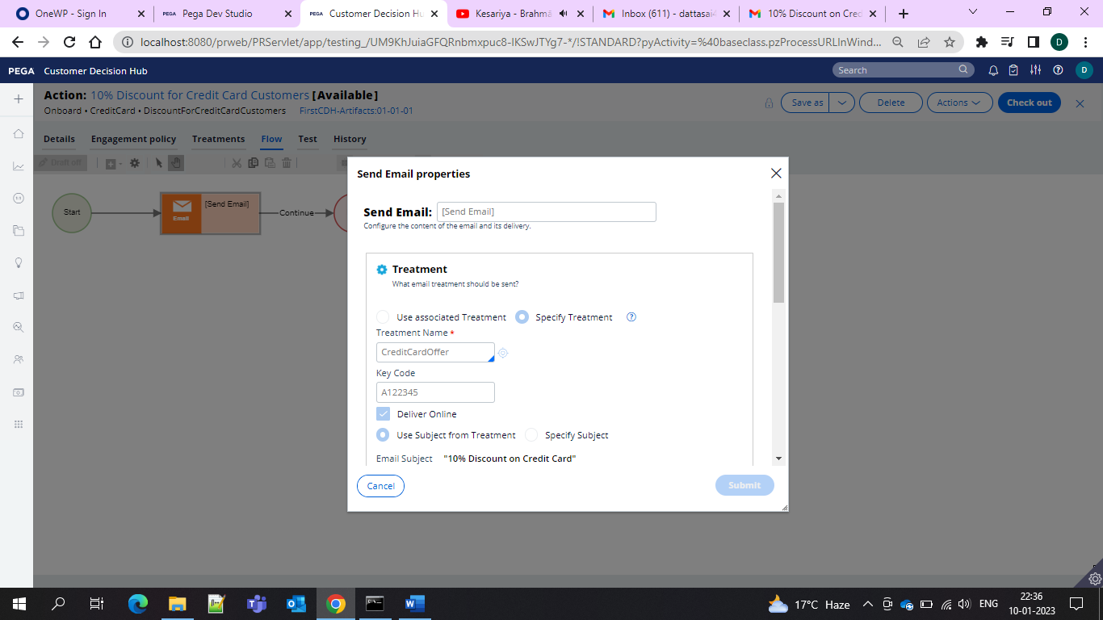

And under the email account you can specify the account or let it be default for now I am specifying the email

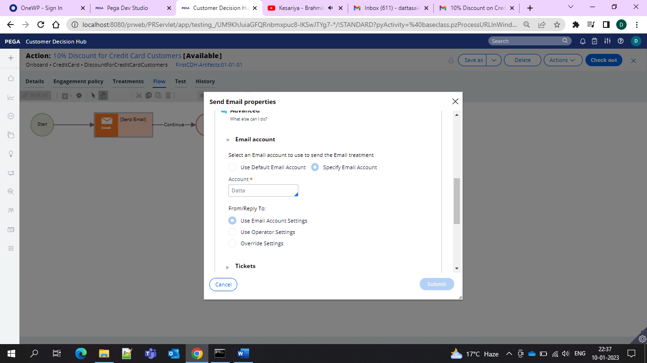

And that’s it now you need to set your set of customers that is audience for which we need to create Segment

For that go to Audience > Segments and create one segment and save it

I Created my Segment as Credit Card Customers

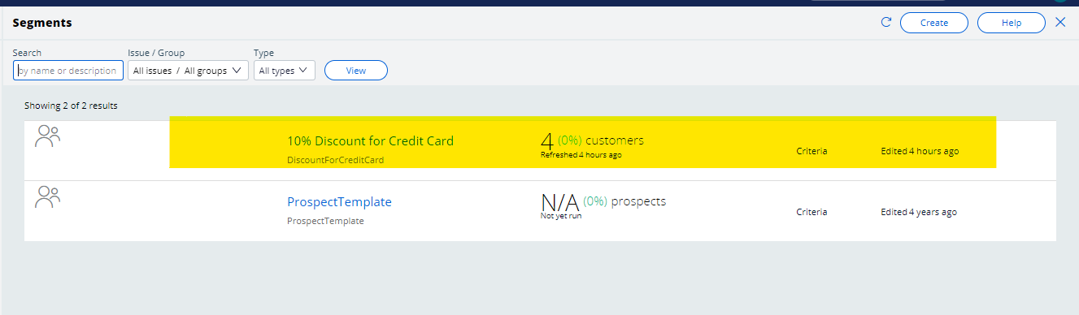

And under that we need to specify our groups and then we need to the configure with the group and the property which you want to target the customer and here I am using Customer ID and in the list select all and save the Segment atleast one context must be given for one group and after the segment creation we can go for the Campaigns where we need to run and trigger the offers.

In this we will have 2 types

Outbound and Multi Channel and

Outbound means one offer for one customer that’s it job done

And if multi channel means “N” offers for “N” Customers.

In our portal we won’t be able to see campaigns on our portal navigation. So for that we need to enable it for enabling we need to go for the Application Settings and search for **ENABLECAMPAIGNEDITION** and then we need to save as into our application ruleset and make true for all the environments and then click save and check In.

And now I created multi channel campaign. And in that there would be action segment and flow and if we specify the action automatically the related flow would populate automatically and then we need to add the segment if it is outbound as below

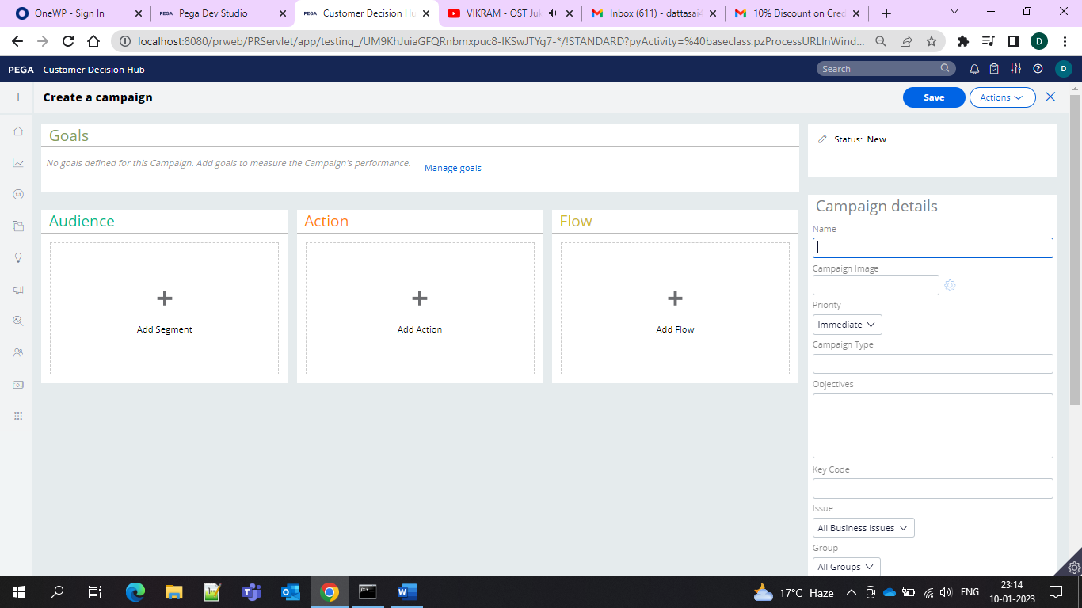  
for the multi channel firectly the interface would be like below

And then we need to give the campaign name and Key Code and this all you need to do in the Plan tab and then in the Build phase you need to provide strategy. Usually NBA_TopLevel is given since it is the main strategy which would be on top of all the markrting strategies where you can push the offer.

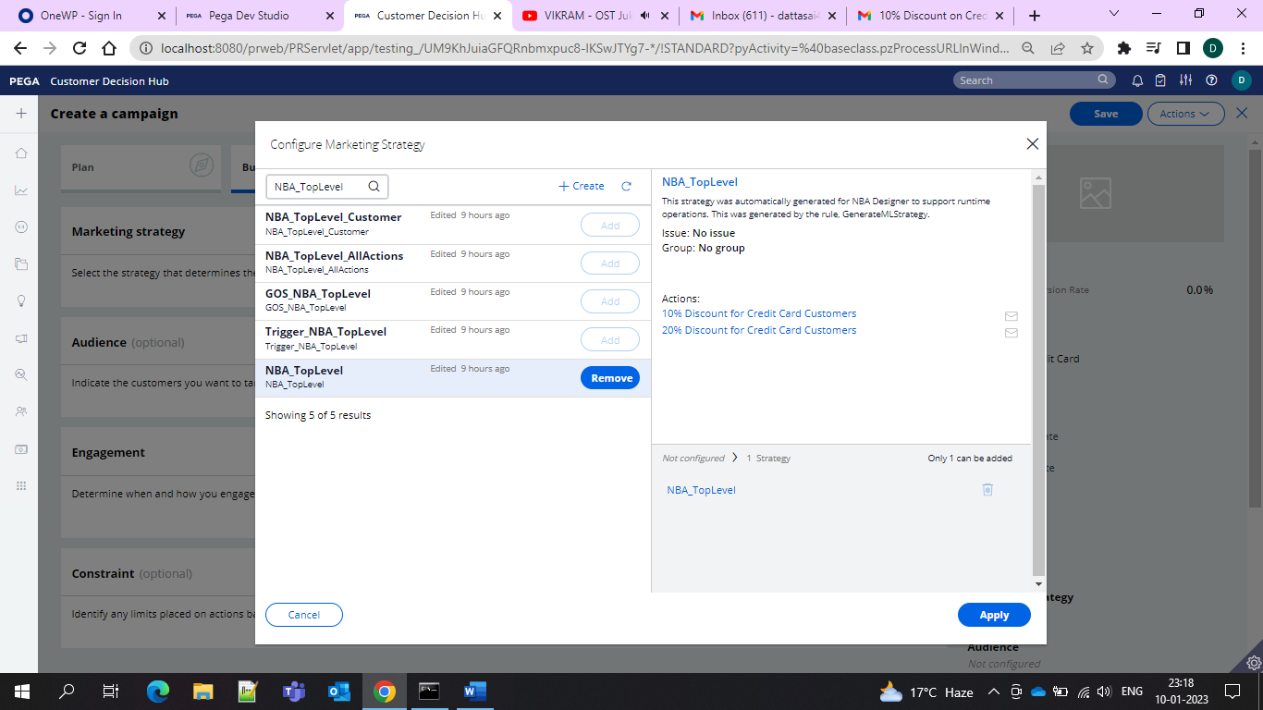

All the related offers are shown here

And then in the audience you can add your segment

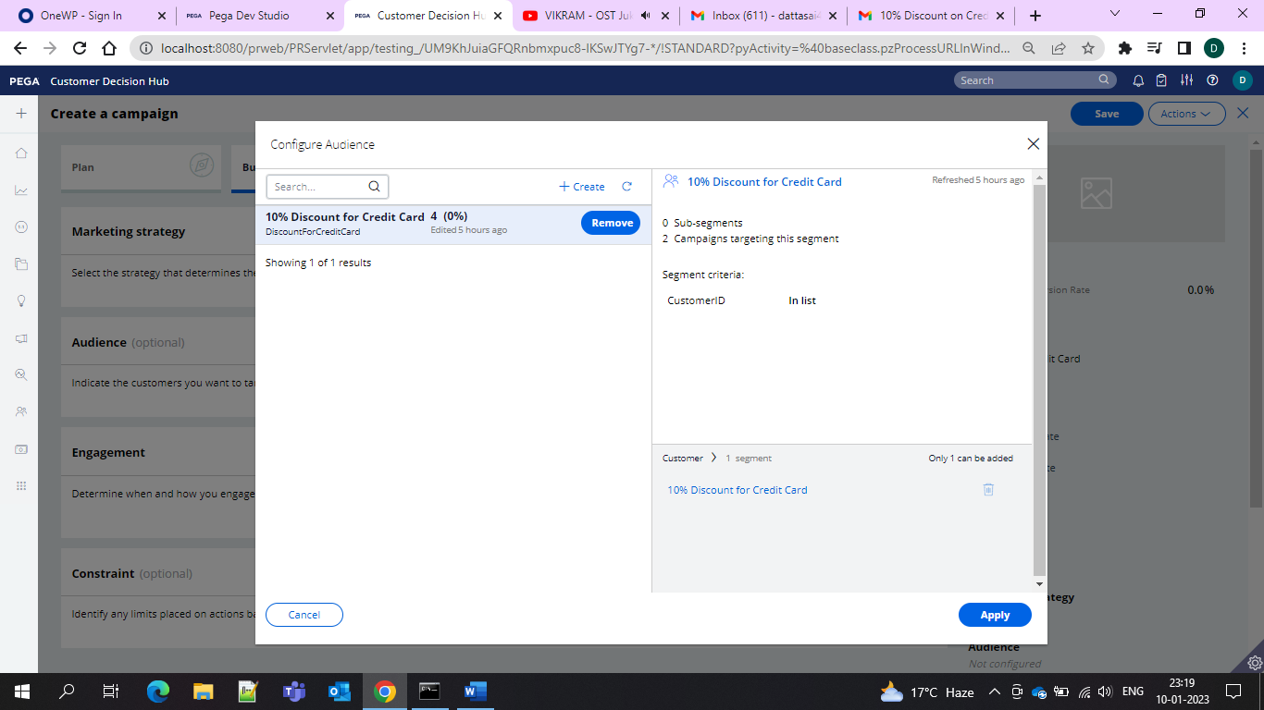

And in the engagement you will have the Campaign Schedule, Real Time Event and Real Time Containers.

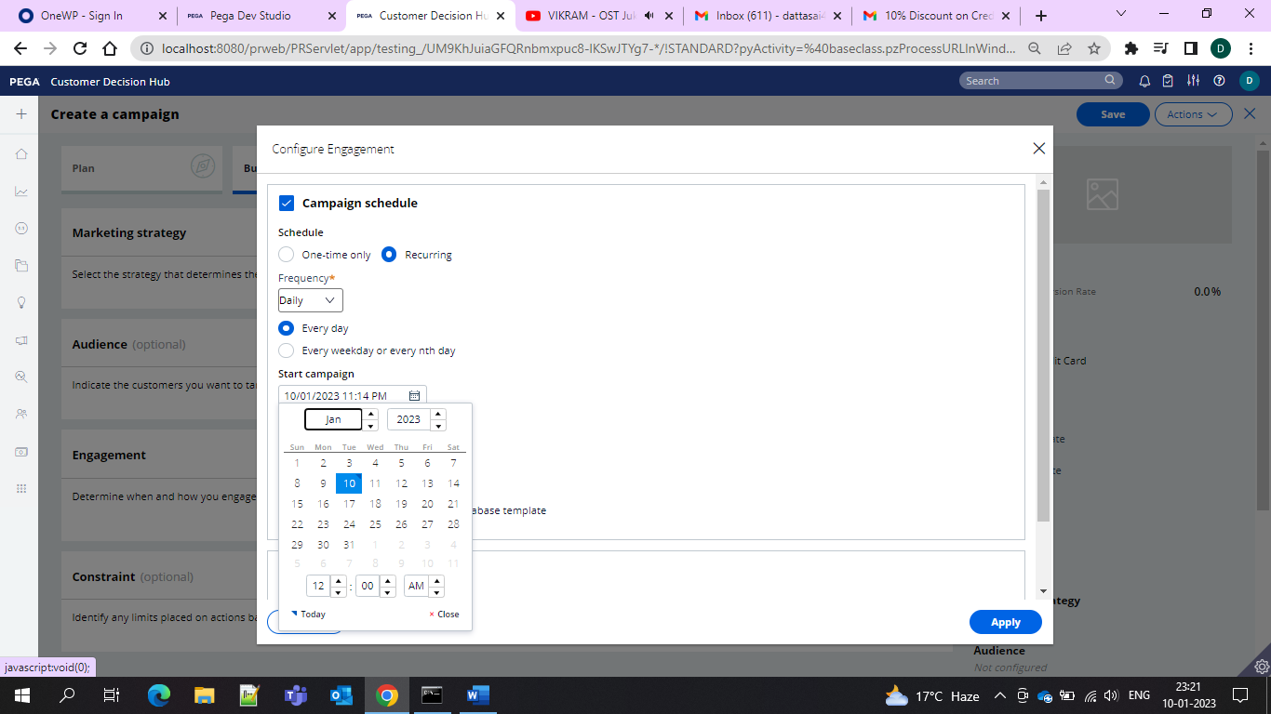

In the campaign schedule you need to give the offers and then you can save and run the campaign and all the offers will go to all the customers.

This is one way if you want to do with the real time events you need to create one event

Basically what is Event Trigger

Event Trigger: When a Realtime event is triggered, it will check for a active campaign (running) and it will be executed.

And if we create one event we would be needing one rest service.

So on the data class you are creating one service package

So I created as Event Invoke

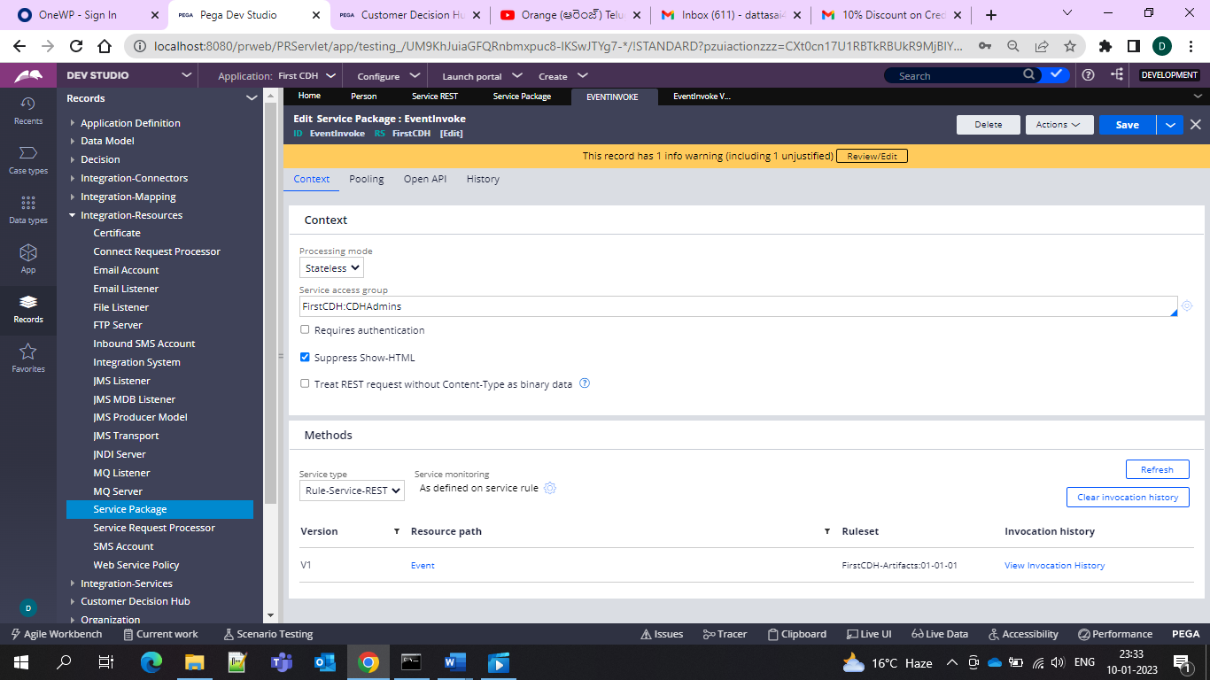

And then you need to create Service REST

And then

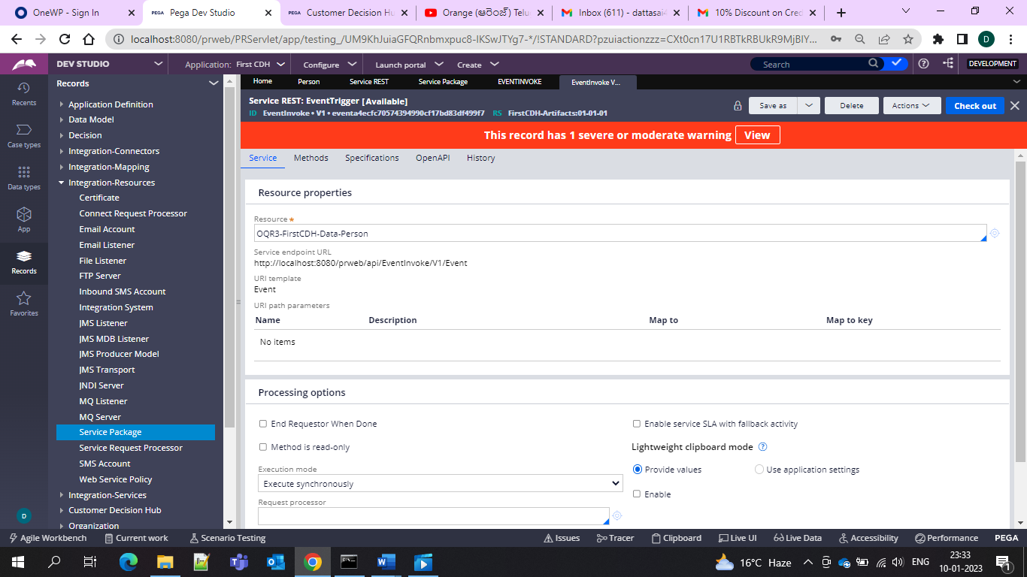

And now keep the URL with you and test in PostMan

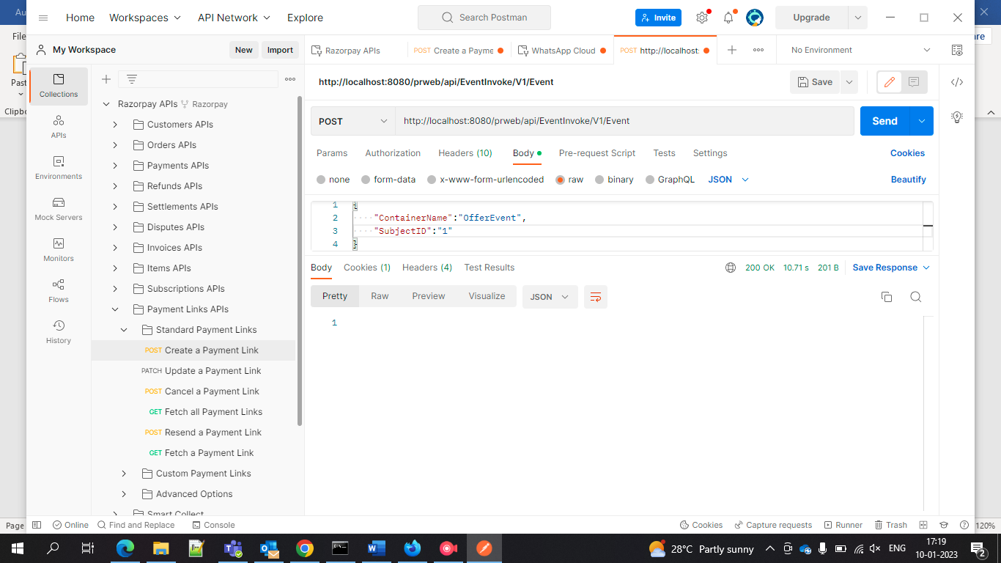

And just give the URL and then in the Body give the CointainerName which is the EventName and then we can subjectID which is the CustomerID and then create two properties as reqpage both as single page properties with the source as our data class

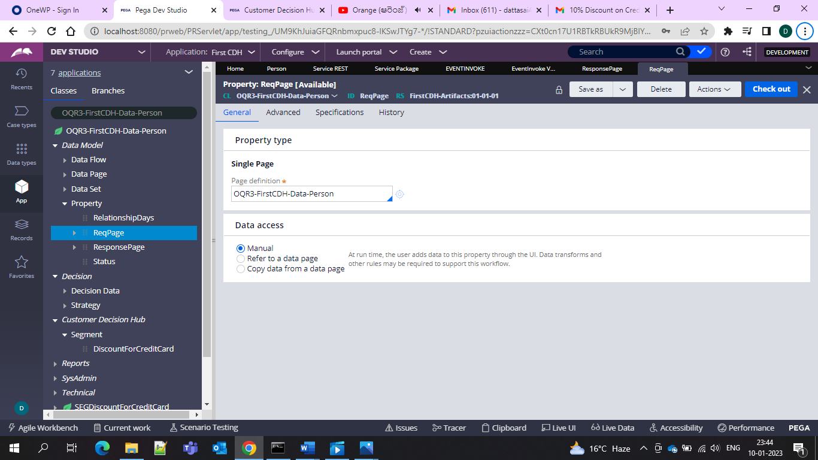

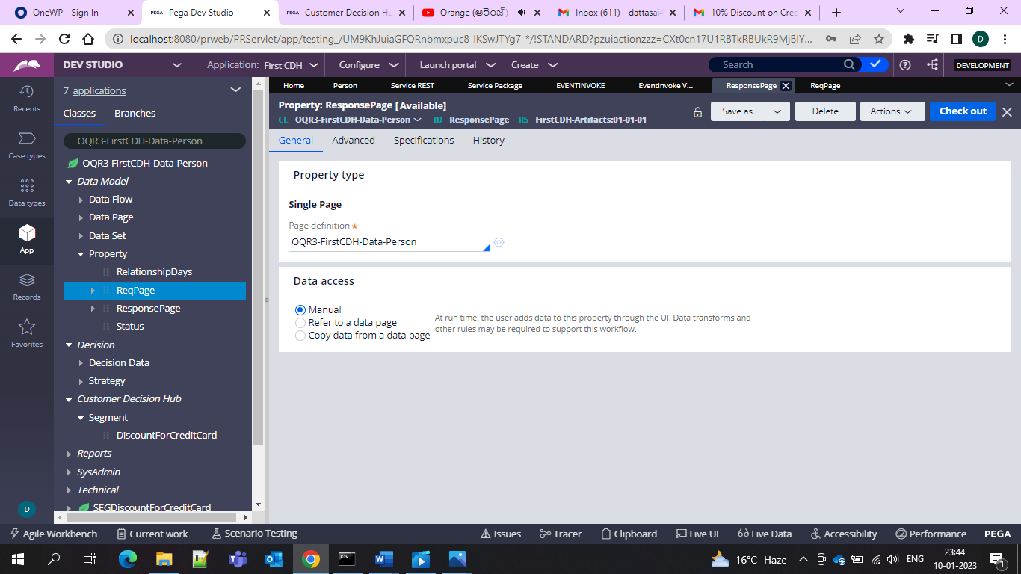

And in the service you can please give the Details as Map from JSON and key as the Respinse Page

And here give the activity as EventTrigger and in that use the method “TriggerMKTEvent” and give the event name and customer ID and in the pages and classes give a page as customer and then give the class as our data class so that we can capture the req page response and give it in the property-set and then once run the activity and go and check in the 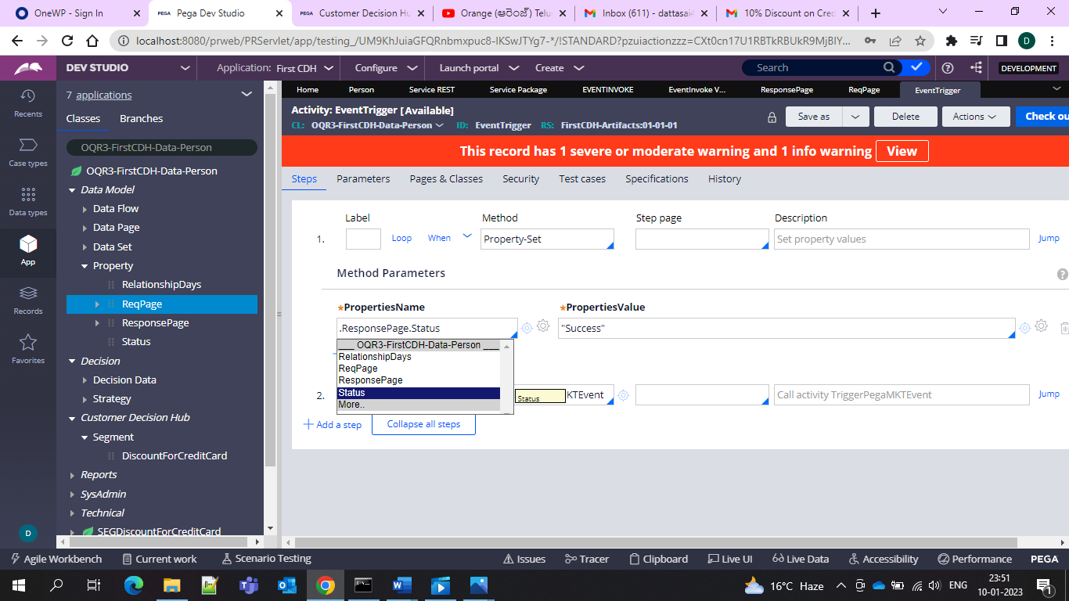

And then once check in the interaction history and check if the Real Time event is running or not

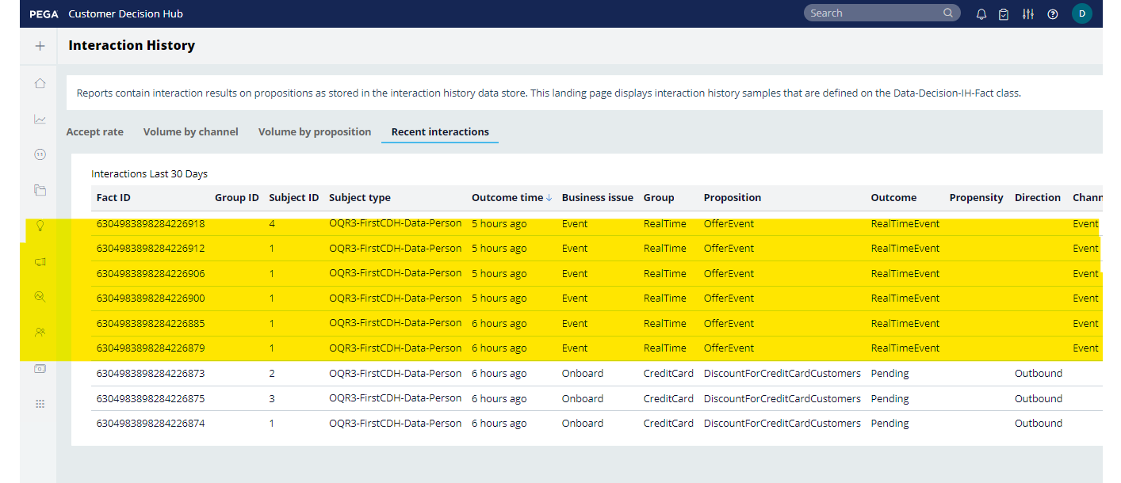

And since I triggered multiple times offer sao it is multiple times and then event is running and the associated campaigns would run automatically and offers would go.

Since we need upon interaction we need to give engagement policy in the Actions so that emails will go to the respective customers

In the engagement policy under the eligibility I gave the condition as if 1 st day please trigger this email

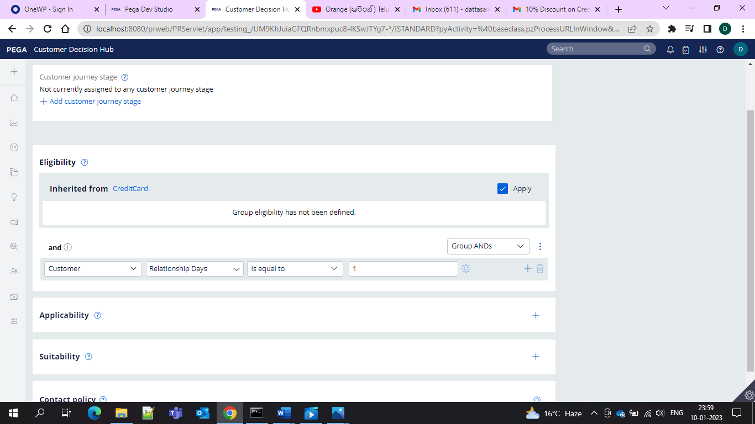

and for the other offer

if it is greater than 3 relationship day then another email must go

so once see in the data type relationship days for the customer

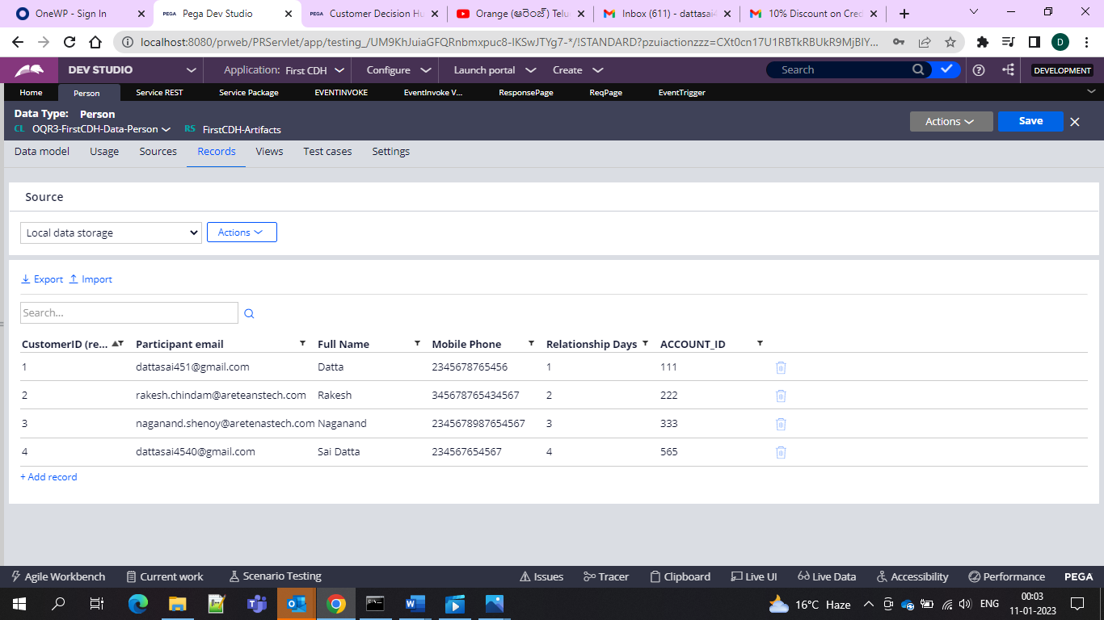

So that means customer ID with 1 must go with the welcome offer and customer ID 4 must go with the Second offer after 4 days offer.Let’s check Gmail

And the offer would be shown like this

Customer 4 with the 20% Discount with relationship more than 3 days condition.

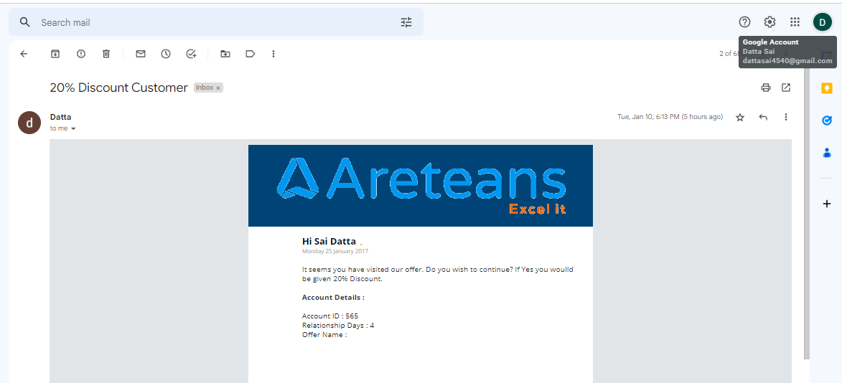

And now welcome offer condition with the customer ID 1

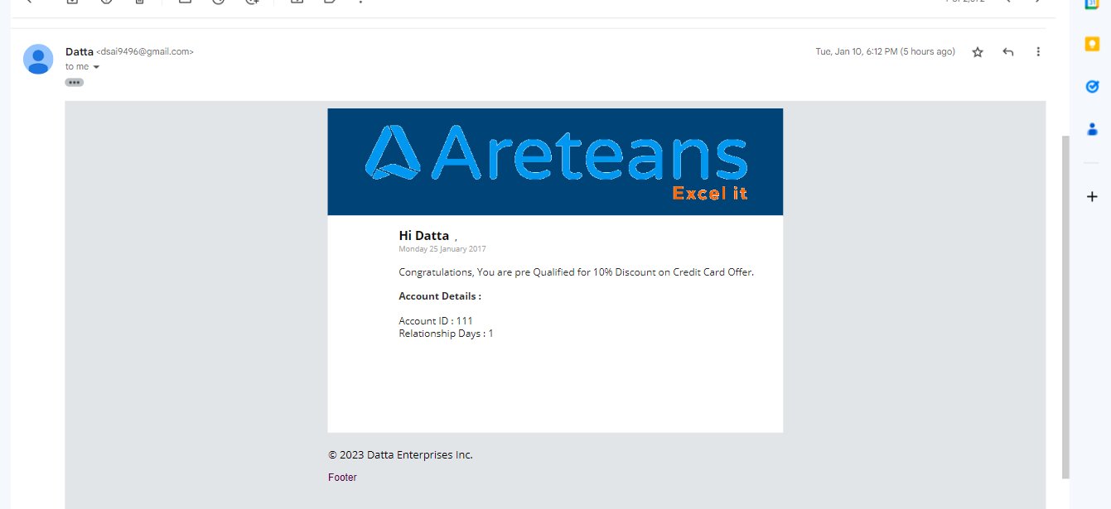

sSo hence engagement is working.

If the rela time event is not given also we can do through campaign schedule and once it is scheduled and ran offers to the eligible customers would be run and here we need to initiate the campaign in real time it is automatically triggered.

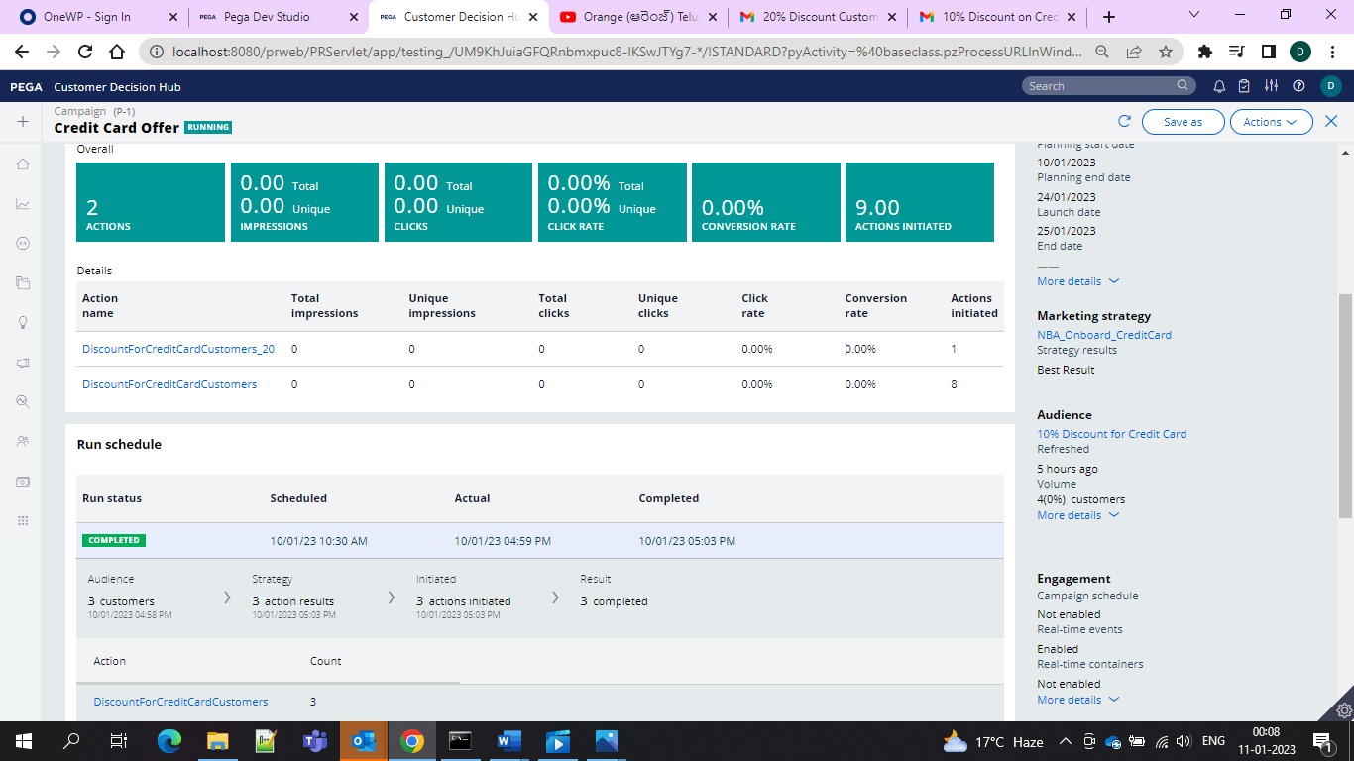

7